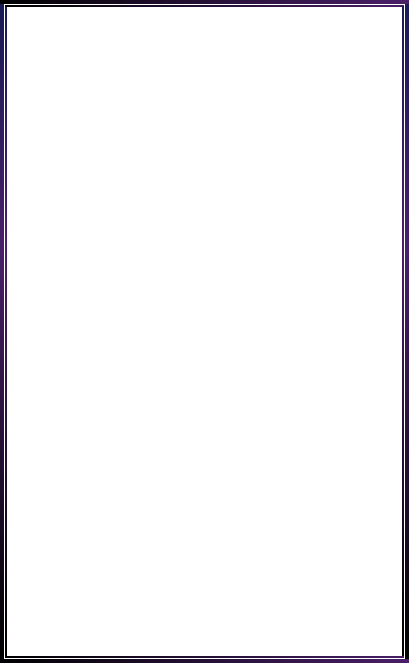

**INNOVATE. CREATE. SOLVE**

Bengaluru, Karnataka, India

AN INTERNSHIP REPORT

ON

“Tribute To LG”

#### Bachelor of Engineering

#### In

#### Computer Science and Engineering

#### 

#### Submitted by: ANANTHAKUMAR M V (4AI18CS005)

#### 

#### 

**Adichunchanagiri Institute of Technology, Chikkamagaluru-577102**

#### 2021

## ABOUT THE COMPANY

IC Solution (ICS) is a digital service provider that aims to provide software, designing and marketing solutions to individuals and businesses. At ICS, we believe that service and quality is the key to success

We provide all kinds of technological and designing solutions from Billing Software to Web Designs or any custom demand that you may have. Experience the service like none other!

Some of our services include:

Development - We develop responsive, functional and super-fast websites.

We keep User Experience in mind while creating websites. A website should load quickly and should be accessible even on a small view-port and slow internet connection.

Mobile Application - We offer a wide range of professional Android, iOS & Hybrid app development services for our global clients, from a start up to a large enterprise.

Design - We offer professional Graphic design, Brochure design & Logo design. We are experts in crafting visual content to convey the right message to the customers.

Consultancy - We are here to provide you with expert advice on your design and development requirement.

Videos - We create a polished professional video that impresses your audience.

**TABLE OF CONTENTS**

Table of contents i

Overview of the Project 1

About LG 2

Why LG Phones are discontinued 3

Tools Used 4

Implementation 5

Snapshots 27

Bibliography 37

About My Team 38

## OVERVIEW OF THE PROJECT

## Project Name: Tribute to LG

**Team Members:** **Mandara R (Team Leader)**

**Aneesh K**

**Ananthakumar M V**

## This project is based on Web Development And its Applications. The main objective of this project is to learn the implementation of HTML, CSS and JavaScript. The basic webpage of this project is created using HTML and styling of the webpage is done using CSS.

## This webpage is about one of the greatest companies of all time.

## LG Electronics is a global innovator in technology and consumer electronics with a presence in almost every country and an international workforce of more than 75,000. LG’s five companies – Home Appliance & Air Solution, Home Entertainment, Mobile Communications, Vehicle component Solutions and Business Solutions – combined for global sales of over USD 56 billion in 2020. LG is a leading manufacturer of consumer and commercial products ranging from TVs, home appliances, air solutions, mobile devices, monitors, service robots, automotive components and its premium LG SIGNATURE and intelligent LG ThinQ brands are familiar names world over.

## ABOUT LG

## LG Electronics is a core company of South Korean conglomerate LG group, alongside LG Chem. Founded in 1958, LG Electronics has led the country's electronics industry since its early days as the first producer of radios, TVs and other appliances. Now, it is the second-largest electronics maker after Samsung Electronics.

## Although LG Electronics lags far behind Samsung in semiconductors and smartphones, the two companies are in close competition in areas such as TVs, washing machines and refrigerators, at home and abroad. Headhunting and patent infringement suits are also common between the two companies. LG Electronics is known for its more laid-back work atmosphere compared to Samsung, which requires its employees to deliver results in a short time.

## Its affiliated companies, such as LG Display and LG Innotek, produce liquid crystal display panels and electronic parts. Amid increased competition with its Chinese rivals in consumer products, LG Electronics aims to boost sales of electronic parts outside the group. It has, for example, set up a division specializing in research and development and supply to automakers.

## Koo Bon-joon, vice chairman of LG Electronics, is the brother of LG Corp. chairman Koo Bon-moo, and the grandson of Koo In-hwoi.

## Why LG phones are discontinued

## LG has finally called it quits to its smartphone business and seeing how the company struggled to make its presence felt over the year, this doesn’t come as a surprise.

## The existing LG phones, such as the Wing, Velvet, Q-series, W-series, and K-series, will continue to sell but that would be until the inventory exists. LG said it will provide service support and software updates for customers of its existing mobile phones for a period that will vary by the customer’s location. This means that it is possible the Velvet in India may not get a software update at the same time as European customers would receive it. The company will work “collaboratively” with suppliers and business partners throughout this period of closure of the mobile division.

## LG said it will wind down the entire mobile phone business by July 31, but the inventory of some of its existing phones may still continue to be available after that. It is not certain how this will come into effect because technically if these phones will be on sale, LG will be providing support and service to these phones. And that would not be called the closure. But it is good for people who are using LG's phones. You do not have to worry much right now because your phone will be supported officially for quite some time.

## LG has a history of launching flagships, mid-range, and budget offerings. Though it started strong, the brand had somehow lost its way in an effort to compete with giants like Apple,

## Samsung, Huawei as well as aggressively priced smartphones from Chinese brands like Xiaomi, OnePlus, and Realme. LG is remembered for launching several innovative phones over the years.

## Sadly, it couldn’t convert them into actual sales mainly because the phones lacked the polish that one would desire after paying a premium.

# TOOLS USED

### Software Requirements

* Visual Studio Code 2019.
* Google Chrome or Microsoft Edge of latest version.
* Front End: HTML, CSS, JS (optional)
* Linux 7.1 or Windows XP/7/8/10 OS or Mac OS

### Hardware Requirements

* Pentium 200-MHz computer with a minimum of 64 MB of RAM (128 MB of RAM recommended).
* Monitor with a refresh rate of at least 40Hz for a smooth GUI experience (optional).

# IMPLEMENTATION

# Source Code (Home.html):

# <!DOCTYPE html>

# <html lang="en" dir="ltr">

# <head>

# <meta charset="utf-8">

# <meta name="viewport" content="width=device-width, initial-scale=1.0">

# <title>Innovations of LG</title>

# <script type="text/javascript">

# var name = prompt("Enter your name");

# alert("Welcome " + name +"!");

# </script>

# <link rel="stylesheet" href="styles.css">

# </head>

# <body class="bground"

# <button onclick="topFunction()" id="btn" title="Go to top">&#8593;</button>

# <script type="text/javascript" src="script.js"></script>

# <button onclick="myFunction()">Dark mode</button>

# <header >

# <img src="./Images/LGlogo.webp" alt="LGlogo">

# <h1>Life's Good</h1>

# <div class="topnav">

# <a class="active" href="#home">Home</a>

# <a href="about.html">About</a>

# <a href="contact.html">Contact</a>

# <input type="text" placeholder="Search..">

# </header>

# <section class="Innovation">

# <h1><u>Seven innovations brought to the smartphone world by LG</u></h1>

# <p>While LG is exiting the smartphone market, the company brought innovation to the smartphone world that is found in today's newest smartphones. LG may soon be gone, it will not soon be forgotten as its technology lives on.</p>

# <p>Take a look at some of the most unique and innovative phones from LG</p>

# <ol>

# <li><a href="#1">Capacitive touchscreen display</a></li>

# <li><a href="#2">Flexible OLED display</a></li>

# <li><a href="#3">Modular smartphone</a></li>

# <li><a href="#4">Ultra-wide camera</a></li>

# <li><a href="#5">Quad DAC</a></li>

# <li><a href="#6">Dual screen Android smartphone</a></li>

# <li><a href="#7">Swivel dual display</a></li>

# </ol>

# </section>

# <hr class="clear">

# <section class="Descriptive">

# <article id="1" class="r">

# <img src="./Images/Prada.jpg" alt="Prada">

# <h1>1. Capacitive touchscreen display</h1>

# <p>When people think of capacitive touchscreen displays on phones, the default belief is that Apple was the first to launch with this technology in the original iPhone. However, LG beat Apple to the punch with the LG Prada that was launched in 2006.</p>

# <p>The LG Prada had a 3-inch capacitive display with a 400x240 pixel resolution. It sported a pretty decent camera, but was priced at $849 in the US so it wasn't that popular.</p>

# </article>

# <hr class="clear">

# <article id="2" class="l">

# <img src="./Images/Flex.png" alt="Flex">

# <h1>2. Flexible OLED display</h1>

# <p>LG released the G Flex with a curved flexible OLED display. It was curved along its length so that it would fit comfortably

# along your face as you held it up for phone calls. It was a rather large phablet phone with a six-inch display, which was very

# large for this time period. </p>

# <p>Competition at the time included the Samsung Galaxy Note 3, which had a smaller form factor and the great S Pen experience. we see foldable phones with flexible displays and can thank LG for leading the way.</p>

# </article>

# <hr class="clear">

# <article class="r" id="3">

# <img src="./Images/Mod.jpg" alt="LG G5 - 2016">

# <h1>3. Modular smartphone</h1>

# <p>The idea of a modular smartphone where you simply slide off various accessories for enhanced functionality sounded good at first when LG launched the LG G5. However, modules never showed up so you were limited to just a removable battery, digital-to-analog converter, and a camera grip. The "LG Friends" never showed up to the party and the G5 didn't do well in the market.</p>

# </article>

# <hr class="clear">

# <article class="l" id="4">

# <img src="./Images/Ultra.jpg" alt="Ultra">

# <h1>4. Ultra-wide camera</h1>

# <p>While the LG G5 modularity wasn't embraced, the LG G5 provided an ultra-wide rear camera on the back. Ultra-wide cameras are now a default

# on mid and upper-level smartphones that have more than one rear camera. LG set this bar and this innovation may be the one that lasts the longest

# after LG departs the smartphone sector.</p>

# <p>LG also had a front-facing ultra-wide camera on the LG V10, which was one of the first times we saw two cameras on the front of a smartphone.</p>

# </article>

# <hr class="clear">

# <article class="r" id="5">

# <img src="./Images/Quad.jpg" alt="Quad">

# <h1>5. Quad DAC</h1>

# <p>LG's V-series was focused on content creators and audiophiles and in 2016 it launched the LG V20 with an integrated quad-DAC for high quality audio playback.

# It may not have been appreciated by everyone, but audiophiles loved the sound produced from an LG V20.</p>

# <p>LG continued providing the standard 3.5mm headphone jack almost up until the end, which was one to two years longer than most other manufacturers.</p>

# </article>

# <hr class="clear">

# <article class="l" id="6">

# <img src="./Images/Dual.jpg" alt="">

# <h1>6. Dual screen Android smartphone</h1>

# 

# <p>While others were looking at foldable phones, LG offered a simple solution with its LG Dual Screen cover that offered a big duplicate display for a much more affordable price. It first launched the LG G8X with this option and then we saw the V50 and V60. The LG Velvet also supported the Dual Screen cover.

# The beauty of this solution was that you could use the dual-display when needed or pop out the phone and use it as a standard phone with ease.</p>

# <p>The dual display was well supported and the LG V60 offered the ultimate experience with extensive support for stylus use. I will continue to use the LG V60 for years because it truly is one of the best smartphones today.</p>

# </article>

# <hr class="clear">

# <article class="r" id="7">

# <img src="./Images/Wing.jpg" alt="">

# <h1>7. Swivel dual display</h1>

# <p>While it was fun to experience the LG Wing with its unique swivel T display, I had trouble finding a practical use for this design other than for shooting video with the gimbal simulation. The lower small display was not very useful so the phone had limited appeal.</p>

# </article>

# <hr class="clear">

# </section>

# <section class="another">

# <h1>See also: </h1>

# <ul>

# <li><a href="phone.html" target="_blank">The Most Famous Phone of LG</a></li>

# <li><a href="lg.html" target="_blank">The Fall of an Icon</a></li>

# </ul>

# </section>

# <footer>

# <div class="wrap"><a href="mailto:lg@google.com">lg@example.com</a> |

# <a href="https://www.lg.com" target="_blank">LG.com</a> |

# <a href="https://twitter.com/LGIndia" target="_blank">Twitter</a> |

# <a href=<https://www.linkedin.com/company/lg-electronics> target="_blank">LinkedIn</a> <br>

# <p>Copyright &copy 2015-2021. All Rights Reserved</p>

# </div>

# </footer>

# </body>

# </html>

# Source Code (about.html):

# <!DOCTYPE html>

# <html lang="en" dir="ltr">

# <head>

# <meta charset="utf-8">

# <title>About</title>

# <link rel="stylesheet" href="styles.css">

# </head>

# <body class="bground">

# <button onclick="topFunction()" id="btn" title="Go to top">&#8593;</button>

# <script type="text/javascript" src="script.js"></script>

# <button onclick="myFunction()">Dark mode</button>

# <header>

# <img src="./Images/LGlogo.webp" alt="LGlogo">

# <h1>Life's Good</h1>

# <div class="topnav">

# <a class="active" href="Index.html">Home</a>

# <a href="about.html">About</a>

# <a href="contact.html">Contact</a>

# <input type="text" placeholder="Search..">

# </div>

# </header>

# <section>

# <div class="some-space">

# <h1>About LG Electronics</h1>

# <p>LG Electronics USA, Inc., based in Englewood Cliffs, N.J., is the North American subsidiary of LG Electronics, Inc., a $53 billion global innovator in technology and manufacturing. In the United States, LG’s focus on Innovation for a Better Life is exemplified by a wide range of innovative home appliances, home entertainment products, mobile phones, commercial displays, air conditioning systems, solar energy solutions and vehicle components. The “Life’s Good” marketing theme encompasses how LG is dedicated to people’s happiness by exceeding expectations today and tomorrow. LG is a 2020 ENERGY STAR® Partner

# of the Year-Sustained Excellence.</p>

# <p>Customers Care specialised in the repair of consumer Home appliances,electronics Products etc. Customers Care are experts in appliance repair with years of experience in fixing a wide range of different appliances. Our highly qualified repair engineers are dedicated to ensuring our clients appliances are repaired as quickly and efficiently as possible, because your satisfaction is our main concern. An average household today uses at least 10 to 15 electrical appliances and electronic devices of varying age and brands & everyday each individual faces such small or big problems.</p>

# </div>

# </section>

# <footer>

# <div class="wrap"><a href="mailto:lg@google.com">lg@example.com</a> |

# <a href="https://www.lg.com" target="_blank">LG.com</a> |

# <a href="https://twitter.com/LGIndia" target="_blank">Twitter</a> |

# <a href=<https://www.linkedin.com/company/lg-electronics> target="_blank">LinkedIn</a> <br>

# <p>Copyright &copy 2015-2021. All Rights Reserved</p>

# </div>

# </footer>

# </html>

# Source Code (contact.html):

# <!DOCTYPE html>

# <html lang="en" dir="ltr">

# <head>

# <meta charset="utf-8">

# <title>Contact</title>

# <link rel="stylesheet" href="styles.css">

# </head>

# <body class="bground">

# <button onclick="topFunction()" id="btn" title="Go to top">&#8593;</button>

# <script type="text/javascript" src="script.js"></script>

# <button onclick="myFunction()">Dark mode</button>

# <header>

# <img src="./Images/LGlogo.webp" alt="LGlogo">

# <h1>Life's Good</h1>

# <div class="topnav">

# <a class="active" href="Index.html">Home</a>

# <a href="about.html">About</a>

# <a href="contact.html">Contact</a>

# <input type="text" placeholder="Search..">

# </div>

# </header>

# <section>

# <div class="contact">

# <form>

# <b>Name:<span style="color:red">* </span></b><input type="text" name="username" placeholder="Your Full Name" required><br><br>

# <b>Phone No.<span style="color:red" >* </span></b>

# <select id="code" name="code">

# 

# <option value="+91">+91</option>

# <option value="">+82</option>

# <option value="">+387</option>

# <option value="">+957</option>

# <option value="">+657</option>

# <option value="">+56</option>

# </select>

# <input type="number" name="phno" value="phno" placeholder="Your Phone Number" max="10" required><br><br>

# <b>Email:<span style="color:red">* </span></b><input type="email" name="email_id" placeholder="Your email" required><br><br>

# <label for="products"><b>Select Your Product:<span style="color:red">* </span></b></label>

# <select id="pdt" name="pdt">

# <option value="Refrigerator">Refrigerator</option>

# <option value="Air-Conditioner">Air-Conditioner</option>

# <option value="Washing Machine">Washing Machine</option>

# <option value="Microwave">Microwave</option>

# <option value="Led">Led TV</option>

# <option value="Lcd">Lcd TV</option>

# </select><br><br>

# <b>Message: </b><br><br> <textarea name="name" rows="8" cols="80" placeholder="Enter Your Message Here..."></textarea><br><br>

# <input type="reset" name="reset" value="Reset">

# <input type="submit" value="Submit">

# </form>

# <hr>

# <div id="info">

# <pre>

# <p>

# <b>Media Contacts:</b>

# LG Electronics USA

# Taryn Brucia

# <a href="mailto:Taryn.Brucia@lge.com">Taryn.Brucia@lge.com</a>

# 201 816 2187

# Tripp Potts

# <a href="mailto:Taryn.Brucia@lge.com">Tripp.Potts@lg-one.com</a>

# 502 235 8040 </p>

# </pre>

# </div>

# </div>

# </section>

# <footer>

# <div class="wrap"><a href="mailto:lg@google.com">lg@example.com</a> |

# <a href="https://www.lg.com" target="_blank">LG.com</a> |

# <a href="https://twitter.com/LGIndia" target="_blank">Twitter</a> |

# <a href=<https://www.linkedin.com/company/lg-electronics> target="_blank">LinkedIn</a> <br>

# <p>Copyright &copy 2015-2021. All Rights Reserved</p>

# </div>

# </footer>

# </html>

# Source Code (lg.html):

# <!DOCTYPE html>

# <html lang="en" dir="ltr">

# <head>

# <meta charset="utf-8">

# <title>Leaving Market</title>

# <link rel="stylesheet" href="styles.css">

# </head>

# <body class="bground">

# <button onclick="topFunction()" id="btn" title="Go to top">&#8593;</button>

# <script type="text/javascript" src="script.js"></script>

# <button onclick="myFunction()">Dark mode</button>

# <header >

# <img src="./Images/LGlogo.webp" alt="LGlogo">

# <h1>Life's Good</h1>

# <div class="topnav">

# <a class="active" href="#home">Home</a>

# <a href="about.html">About</a>

# <a href="contact.html">Contact</a>

# <input type="text" placeholder="Search..">

# </div>

# </header>

# <div style="height:500px;">

# <section class="l">

# <div class="wrap">

# <img src="./Images/LG2.jpg" title="LG" alt="LG">

# <p>LG has finally called it quits to its smartphone business and seeing how the company struggled to make its presence felt over the year, this doesn’t come as a surprise. LG has a history of launching flagships, mid-range, and budget offerings. Though it started strong, the brand had somehow lost its way in an effort to compete with giants like Apple, Samsung, Huawei as well as aggressively priced smartphones from Chinese brands like Xiaomi, OnePlus, and Realme. LG is remembered for launching several innovative phones over the years. Sadly, it couldn’t convert them into actual sales mainly because the phones lacked the polish that one would desire after paying a premium.</p>

# </div>

# </section>

# </div>

# <footer class="clear">

# <div class="wrap"><a href="mailto:lg@google.com">lg@example.com</a>

# <a href="https://www.lg.com" target="_blank">LG.com</a>

# <a href="https://twitter.com/LGIndia" target="_blank">Twitter</a>

# <a href=<https://www.linkedin.com/company/lg-electronics> target="_blank">LinkedIn</a> <br>

# <p>Copyright &copy 2015-2021. All Rights Reserved</p>

# </div>

# </footer>

# </body>

# </html>

# Source Code (phone.html):

# <!DOCTYPE html>

# <html lang="en" dir="ltr">

# <head>

# <meta name="Tribute to LG" charset="utf-8">

# <title>The Most Famous Phone of LG</title>

# <link rel="stylesheet" href="styles.css">

# </head>

# <body class="bground">

# <button onclick="topFunction()" id="btn" title="Go to top">&#8593;</button>

# <script type="text/javascript" src="script.js"></script>

# <button onclick="myFunction()">Dark mode</button>

# <header>

# <img src="./Images/LGlogo.webp" alt="LGlogo">

# <h1>Life's Good</h1>

# <div class="topnav">

# <a class="active" href="Index.html">Home</a>

# <a href="about.html">About</a>

# <a href="contact.html">Contact</a>

# <input type="text" placeholder="Search..">

# </div>

# </header>

# <section class="phones" >

# <h1><u>The Most Famous LG Phone</u></h1>

# <div class="l">

# <img src="./Images/LG3.jpg" alt="LG V60 ThinQ 5G">

# </div>

# <h3>SPECIFICATIONS: </h3>

# <p>Release date: March 2020 Weight: 218g</p>

# <p>Dimensions: 169.3 x 77.6 x 8.9 mm</p>

# <p>OS: Android 10Screen size: 6.8-inch</p>

# <p>Resolution: 1080 x 2460CPU: Snapdragon 865</p>

# <p>RAM: 8GBStorage: 128GBBattery: 5,000mAh</p>

# <p>Rear camera: Dual 16MP + 13MP</p>

# <p>Front camera: 10MP</p>

# <div class="clear">

# <p>The LG V60 is the best LG phone for some time. It has a big, bright display that looks great, although it only has a 60Hz refresh rate - normal for most phones, but similar spec flagships like the OnePlus 8 Pro and Samsung Galaxy S20 have 120Hz, making them more fluid looking.</p>

# <p>The V60 excels in battery life with a genuine two day battery life, top performance from the Snapdragon 865 chip and 5G compatibility. Most purchases also come with the Dual Screen case. It’s bulky, but adds a second screen so you can run two apps side by side or use it as a Nintendo 3DS-style game pad.</p>

# 

# <p>With a Quad-DAC headphone jack and superb video controls for the dual cameras, the LG V60 is a content creator’s ideal smartphone.</p>

# </div>

# </section>

# <footer>

# <div class="wrap"><a href="mailto:lg@google.com">lg@example.com</a> |

# <a href="https://www.lg.com" target="_blank">LG.com</a> |

# <a href="https://twitter.com/LGIndia" target="_blank">Twitter</a> |

# <a href=<https://www.linkedin.com/company/lg-electronics> target="_blank">LinkedIn</a> <br>

# <p>Copyright &copy 2015-2021. All Rights Reserved</p>

# </div>

# </footer>

# </body>

# </html>

# IMPLEMENTATION

# Source Code (Style.css):

# header {

# background: #FF6F61;

# color: #F7FFF7;

# text-align: center;

# height: auto;

# border: 4px solid black;

# }

# header h1 {

# color: #cc0000;

# padding-top: 20px;

# padding-bottom: 20px;

# background-color: black;

# }

# header img {

# width: 150px;

# height: 138px;

# margin-right: 0;

# }

# .topnav {

# overflow: auto;

# background-color: #e0e0e0;

# }

# .topnav a {

# float: left;

# display: block;

# color: black;

# text-align: center;

# padding: 14px 16px;

# text-decoration: none;

# font-size: 17px;

# }

# .topnav a:hover {

# background-color: #ddd;

# color: black;

# }

# .topnav a.active {

# background-color: #2196F3;

# color: white;

# }

# .topnav input[type=text] {

# float: right;

# padding: 6px;

# border: none;

# margin-top: 8px;

# margin-right: 16px;

# font-size: 17px;

# }

# body {

# color: #343434;

# font-family: 'Montserrat', sans-serif;

# font-size: 15px;

# line-height: 1.5;

# }

# .dark-mode {

# background-color: black !important;

# color: white !important;

# }

# .contact {

# margin-top: 50px;

# height: 700px;

# }

# #info {

# text-align: left;

# margin-left: -100px !important;

# margin-top: -50px;

# }

# a{

# color: blue;

# }

# a:hover {

# text-decoration: none;

# color: white;

# }

# h1, h2 {

# font-family: 'Caveat', cursive;

# font-weight: 400;

# margin: 0;

# }

# img {

# float: left;

# }

# img {

# width: 10%;

# transition: 0.5s all ease-in-out;

# }

# .l:hover img {

# transform: scale(1.05);

# overflow: hidden;

# /* margin: 0 auto; */

# }

# .r:hover img {

# transform: scale(1.05);

# }

# .phones img{

# float: left;

# width: 300px;

# height: 300px;

# margin-right: 20px;

# margin-bottom: 20px;

# border: 5px solid #555;

# }

# .l img {

# float: left;

# width: 300px;

# height: 300px;

# margin-right: 20px;

# margin-bottom: 20px;

# border: 5px solid #555;

# }

# .r img {

# float: right;

# width: 300px;

# height: 300px;

# margin-right: 20px;

# margin-bottom: 20px;

# border: 5px solid #555;

# }

# .clear {

# clear: both;

# }

# .bground {

# background: #F3E0BE;

# }

# .some-space{

# height: 500px;

# }

# .phones h1{

# margin: 10px;

# }

# .another a{

# color: #FF6F61;

# }

# hr {

# border-top:1px dotted #000;

# }

# section {

# width: 900px;

# margin: 0 auto;

# }

# #btn {

# display: none;

# position: fixed;

# bottom: 20px;

# right: 30px;

# z-index: 99;

# border: none;

# outline: none;

# background-color: #555;

# color: white;

# cursor: pointer;

# padding: 15px;

# border-radius: 10px;

# font-size: 18px;

# }

# #btn:hover {

# background-color: red;

# }

# footer a {

# color: yellow;

# }

# footer {

# padding-top: 20px;

# background: #343434;

# color: #F7FFF7;

# text-align: center;

# height: auto;

# }

# Source Code (Script.js):

var mybutton = document.getElementById("btn");

window.onscroll = function() {scrollFunction()};

function scrollFunction() {

if (document.body.scrollTop > 20 || document.documentElement.scrollTop > 20) {

mybutton.style.display = "block";

} else {

mybutton.style.display = "none";

}

}

function topFunction() {

document.body.scrollTop = 0;

document.documentElement.scrollTop = 0;

}

function myFunction() {

var element = document.body;

element.classList.toggle("dark-mode");

}

# IMPLEMENTATION

# Snapshots:

# Home Pages

# 

# 

# 

# 

# 

# 

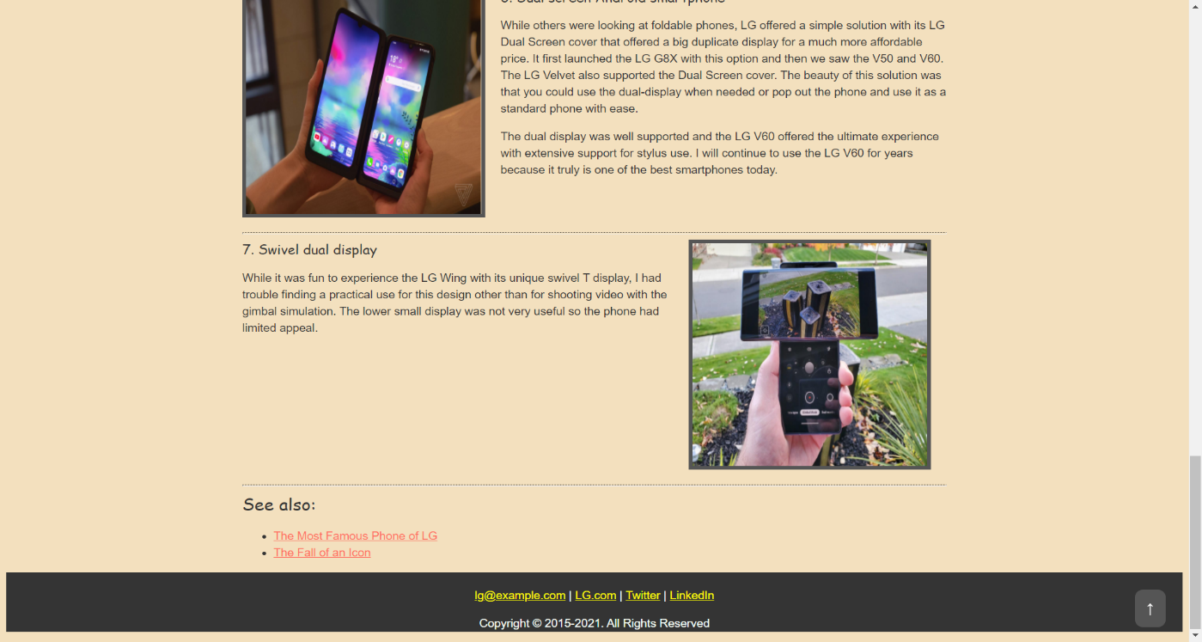

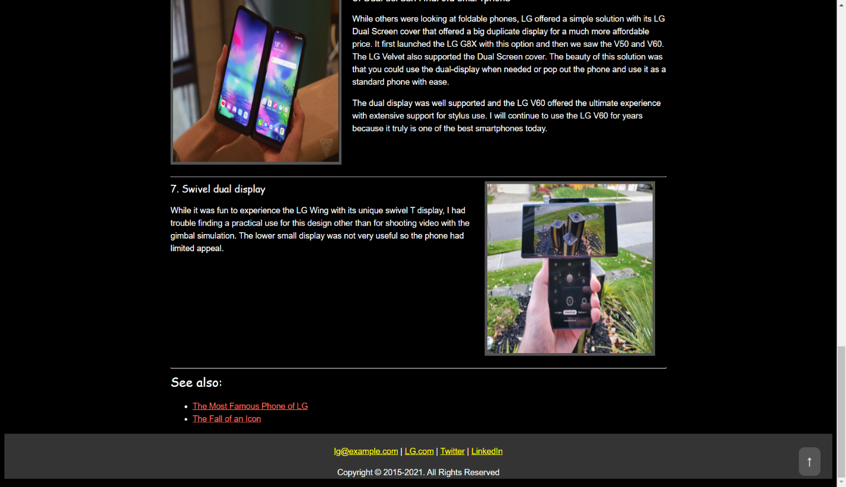

# About page

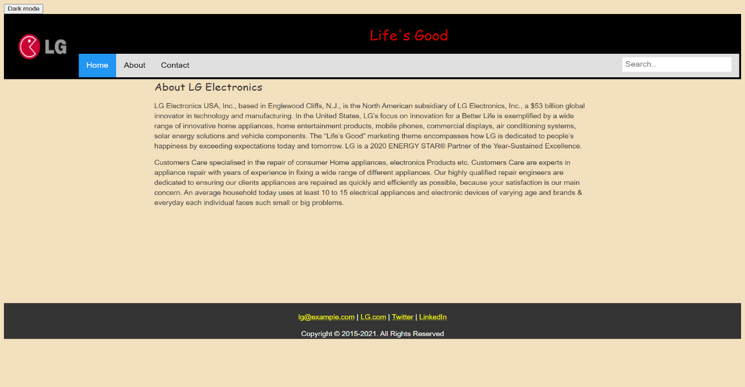

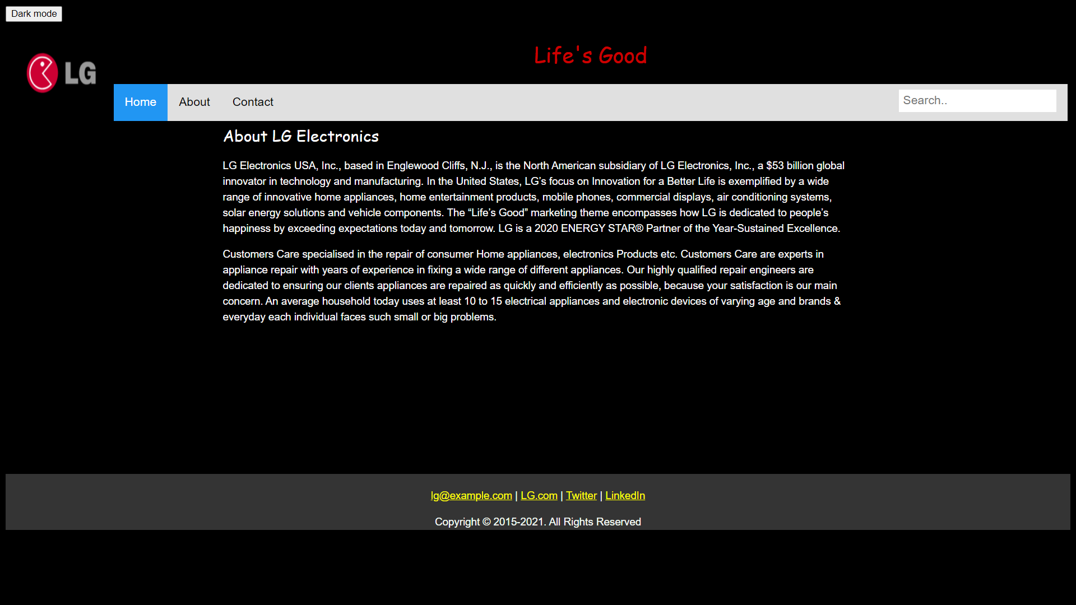

1. **Contact**

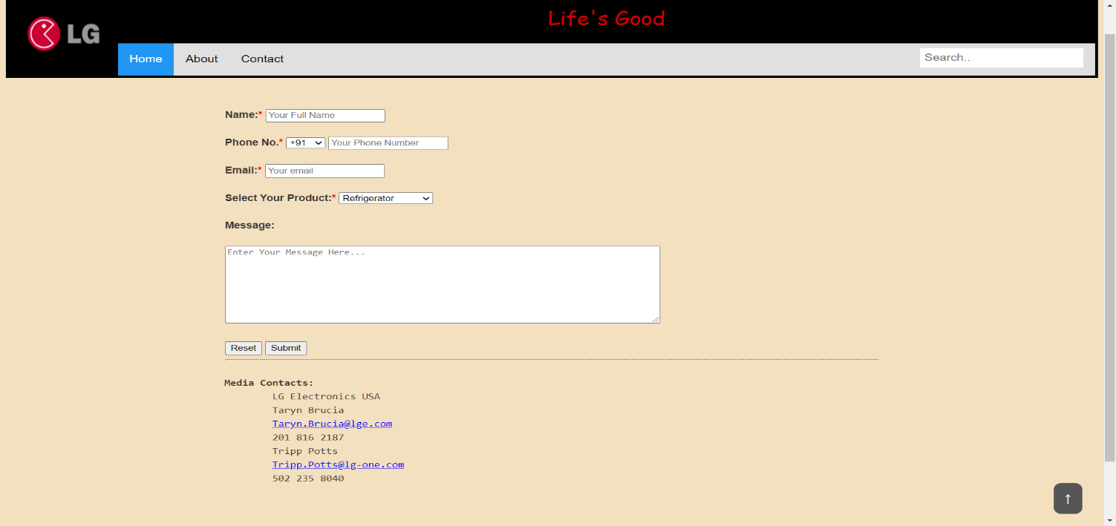

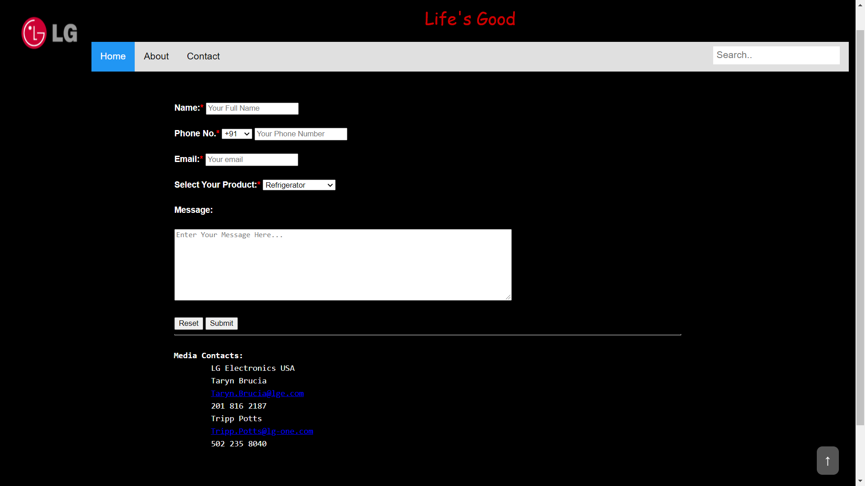

1. **The Fall of an Icon Page**

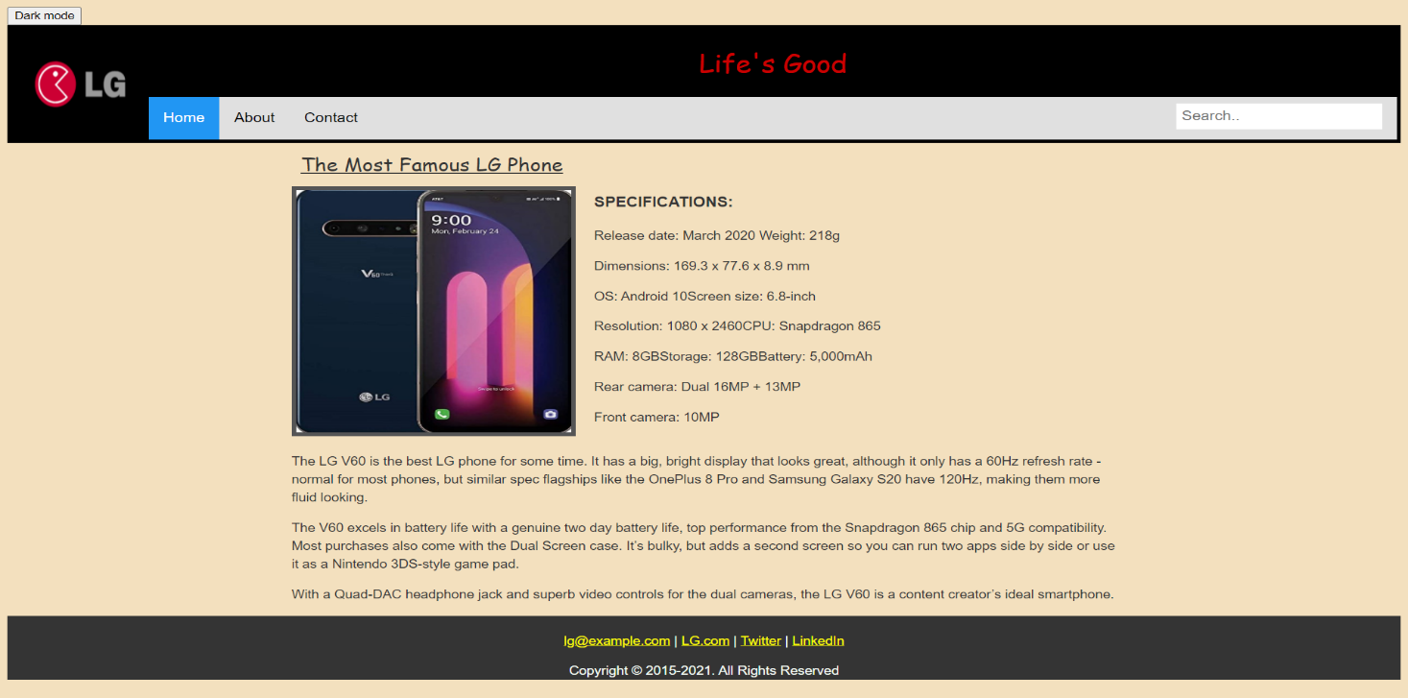

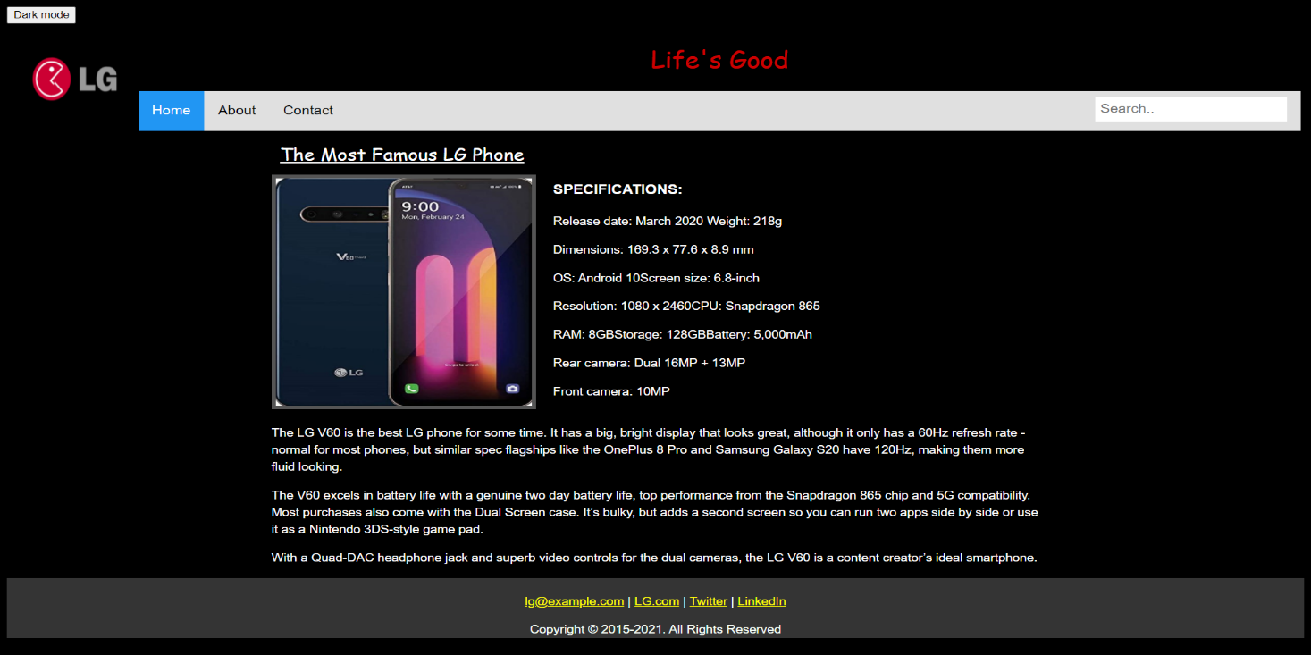

1. **The Most Famous LG Phone**

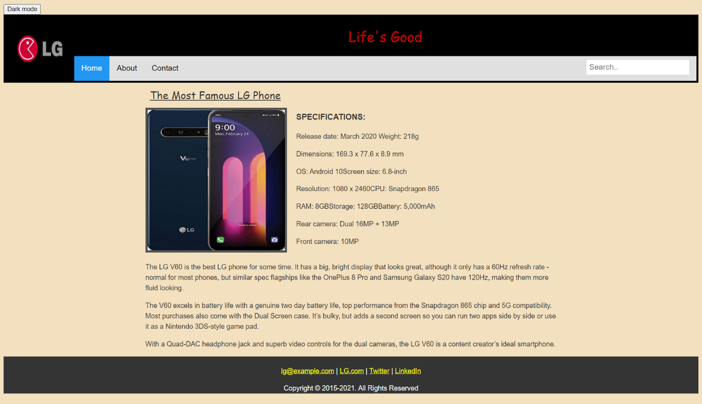

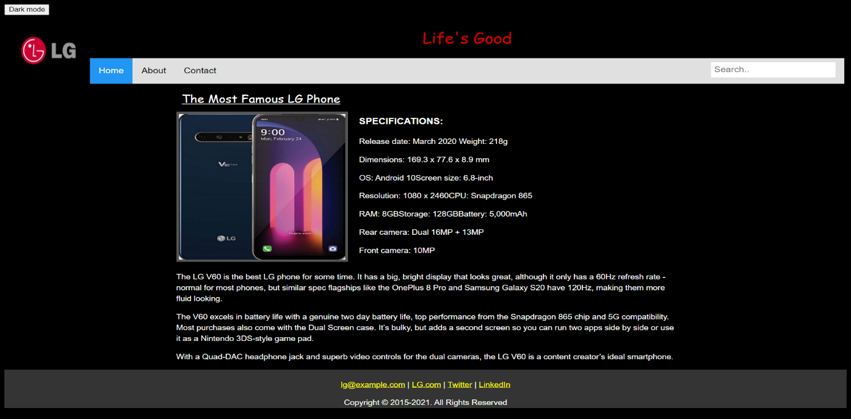

**BIBLIOGRAPHY**

* https://[www.w3schools.com](http://www.w3schools.com/)
* https://[www.geeksforgeeks.org](http://www.geeksforgeeks.org/)
* https://freefrontend.com
* https://medium.com

## About My TEAM

**Role Played by our Teammates:**

1. Report: Aneesh K
2. HTML: Mandara R
3. CSS and JS: Ananthakumar M V

* Firstly, we created a roadmap about our project to finish things up.
* We helped one another to reach their milestone.
* We communicated well with each other.
* We worked collaboratively.
* While working on the project, we had so much fun.
* Good Leadership.
* We have learnt a lot.
* Everyone contributed equally to finish this project.
* We also had one-on-one conversation.
* Lastly, we have achieved our objective.